**Boiling Temperature**

When water is heated it will eventually boil and turn into steam. The temperature at which water boils is called its ‘boiling point’. In this activity you will make use of some of the skills you have just learned to find out the boiling point of water.

**MATERIALS REQUIRED:**

* 250 mL beaker • thermometer
* stopwatches • tripod
* matches • gauze mat
* Bunsen burner

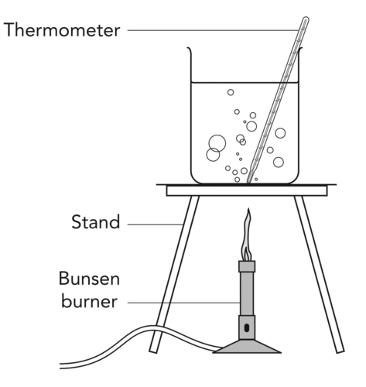

**METHOD:**

1. You will be measuring the temperature of some water each minute while the water is heated. Put suitable headings into the table prepared for you below.
2. Fill the beaker with 100 ml of water (approximate is fine)
3. Place the beaker on the gauze mat and tripod.
4. Place the thermometer in the beaker and read the temperature of the water. This is when time = 0 in your table
5. Light the Bunsen burner and heat the water steadily. Start timing.
6. Record the temperature of the water every minute.
7. Continue the heating process for at least 3 minutes after boiling begins (boiling is when large bubbles rapidly form).
8. Draw a line graph plotting temperature of the water against the heating time.

**TABLE**

**Heading for independent variable Heading for dependent variable**

|  |  |
| --- | --- |
|  |  |
|  |  |
|  |  |
|  |  |
|  |  |
|  |  |
|  |  |
|  |  |
|  |  |
|  |  |
|  |  |
|  |  |

**GRAPH – Draw a graph based on your table data**

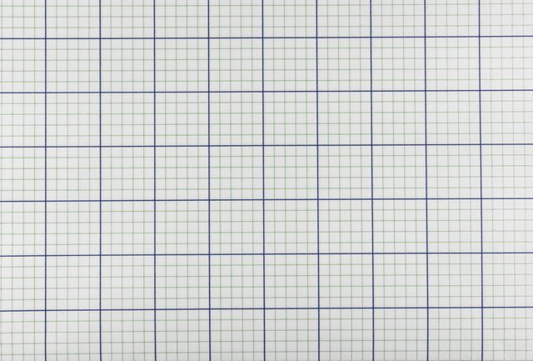

**Conclusion**

1. **What temperature do you think the water was boiling at? How do you know based on your graph?**